**Sheena Arora 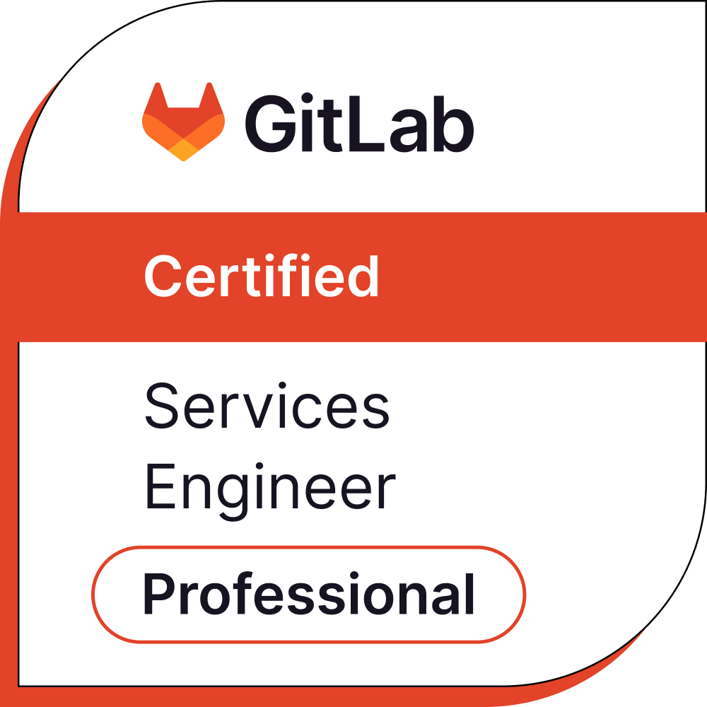 DevOps Engineer**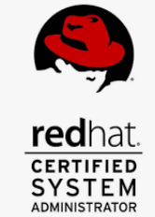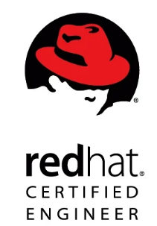

**Mobile: +61 477802284 Email: sarora0109@gmail.com**

**LinkedIn -** [**https://www.linkedin.com/in/sh33na**](https://www.linkedin.com/in/sh33na) **Visa Status: Permanent Resident(PR)**

**Experience**

With over 10 years of IT experience as a DevOps Engineer, RHCE certified and Gitlab PSE. Strong experience in Ansible, Terraform Associate, Linux Administrator, Continuous Integration and continuous delivery, VMWare data centre and desktop virtualisation, Strong experience in automating admin tasks. Well versed with Configuration management tools like Ansible and Jenkins. Provide management support for IT systems upon establishing and maintaining networks and servers. Strong aptitude for identifying new technologies and solutions to support client needs.

**Professional Summary and responsibilities**

* **DevOps Reporting Manager** with a proven track record of leading a team of 6 DevOps engineers, managing both technical and personnel responsibilities.
* Over 4 years of experience with container orchestration tools like **Kubernetes** and **Rancher**.
* Skilled in adopting and implementing complex technologies, including **Ansible** and **Terraform**, to provision and efficiently manage cloud resources.
* Extensive experience with version control systems such as **Git**, **GitHub**, and **SVN**.
* Proficient in **Azure** and **AWS** services, specifically EC2, S3 Buckets, and IAM.
* Developed and maintained multi-project CI/CD pipelines using tools like **Jenkins**, **BitBucket**, **Bamboo**, and **GitLab**.
* Experienced in configuring web servers, including **Nginx**, **Apache**, and **OHS**.
* Strong background in **VMware** Administration, including creating VMs, managing networking, and developing templates.
* Implemented and maintained **Proxmox** as a virtual manager tool for proof of concept (POC) projects.
* Extensive experience in building, configuring, and troubleshooting Linux servers.
* Strong experience in logging and monitoring using **nagios**,**icinga**, **prometheus**,ELK Stack and
* Proficient in scripting with **Python** and **Bash** for task automation and scheduling.

## Skills and competencies

|  |  |
| --- | --- |
| Infrastructure as code Tool | Terraform, Ansible. |
| CI/CD Tool | Jenkins, Bamboo, BitBucket, Gitlab, Argo CD |
| Container management tool | Docker, Azure ACI, AWS ECS. Openshift, Rancher, Rke2, Kubernetes |
| Virtualization | VMWare, Proxmox, harvester |
| Source control | Git,, SVN, Gitlab |
| Scripting | Bash |
| Artifactory tool | JFrog, Nexus |
| Monitoring and comparison | Splunk, Icinga, Nagios, Prometheus, Graphana |
| Linux administration | Redhat, Fedora, Ubuntu, centos |
| Cloud platform | AWS, Azure |

**EXPERIENCE SUMMARY:**

**Adfinis IT, Australia** **Projects - Multiple**

**DevOps Engineer May 2024 – Present**

* Implementing CI/CD pipelines using GitLab to automate the deployment process for microservices architecture.
* Implemented Monitoring like Prometheus and Grafana in Openshift and Rancher.
* Utilising Ansible for configuration management and automation to standardise and streamline server provisioning and deployment processes.
* Created POC using terraform,Rancher, Rke2, ArgoCD in AWS.
* Collaborated with development teams to streamline processes and improve code quality through code reviews, unit testing, and version control with Git
* Monitor system performance and implemented alerts using tools like Icinga and Prometheus to proactively identify and resolve issues before they impact end users.
* Migrating projects to from Bitbucket, self manged Gitlab to Gitlab.com using Congregate

**HCL Technologies, Malaysia Project – Great Eastern Malaysia/Singapore**

**DevOps Engineer ( Technical Lead) Nov 2021 - May 2021**

* Supervising more than 25 Linux based-Servers from Development, QA and Production and monitoring their CPU, storage and memory
* Deployment of Java-based spring services(microservices) on Rancher ( Kubernetes)
* Responsible for system upgrades, certificates on Kubernetes(Rancher) where all the java-based microservices are deployed
* Accelerated as Technical & Mg lead for a team of six, responsibilities include prioritizing jobs as per requirements & planning roster
* Constructed daily CI/CD process using Bash Scripting, Ansible, Jenkins so as to reduce the redundancy on manual process 6. Securing Credentials and certificates using CyberArk
* Enrolled complex concepts & technologies including git, Docker, and using OHS as a web-server

**SICPA, Malaysia Projects- Russia Pharma, Philipines Oil & Gas**

**DevOps Engineer Oct 2018- Nov 2021**

* Implemented and managed continuous integration and continuous deployment (CI/CD) pipelines using tools like Jenkins, GitLab CI/CD, or CircleCI to automate software delivery processes
* Implemented RedHat Openshift for deploying java based microservices.
* Developed and maintained infrastructure as code (IAC) using tools like Terraform, Ansible to provision and manage cloud resources efficiently
* Collaborated with cross-functional teams to streamline development and operations processes and improve overall system reliability and scalability
* Monitored and optimized system performance, security, and cost using tools like Prometheus, Grafana, Splunk, to ensure high availability of applications
* Implemented disaster recovery strategies and conducted regular backups to minimize downtime and ensure data integrity in case of system failures
* Worked on Agile and Scrum methogologies to plan and check day to day tasks.

**HCL Technologies, Malaysia Projects - Intel**

**DevOps Engineer and AEM Admin March 2018 - Sep 2018**

* Handled the position on Lead Dev Operation for contractual position in Intel
* Worked on Github, Jenkins & Ansible and excelled on maintaining the web server - apache
* Worked on migration of CMS tool from CQ5 to AEM 6
* Daily build and deployment on testing and qa environments and also weekly deployment on production
* Automate redundant tasks with bash scripting and curl.
* Optimising and maintaining apache with rewrite rule and replication and clustering

**Publicis, Sapient, Noida, India Project – Goldman Sachs, USA**

**DevOps Engineer July 2014 - March 2018**

* Deployment and operations tasks throughout all stages of the development lifecycle.
* Responsible of taking care more than 200 VM’s deployed for Dev, QA and Prod.
* Administrating & core responsible of CMS tools like Adobe CQ (6.1), Adobe AEM (5.6.1) and Atlassian Confluence (5.0.2)
* Daily build and deployment on testing and qa environments and also weekly deployment on production.
* Optimising and maintaining apache with rewrite rule and replication and clustering.
* Administrator of Adobe CQ5 application
* Configuring monitoring using Nagios and adding new hosts as per requirement.
* Carrying out regular activities of build and deployment using Jenkins
* Maintaining Shell Scripts for Backup and other daily basis tasks

**HCL technologies, Noida, India Project - Ebay**

**Linux System Administrator June 2012 -July2014**

* Handling the profile of Release Manager & System administrator.
* Maintaining/Configuring web-server (apache) and providing Weblogic Support as per application requirement.
* User Administration, patch and File management on Linux servers.
* Monitoring using open source tools like Nagios & bugzilla.
* Coordinated the implementation of the infrastructure releases. and Maintenance of weblogic servers
* Managing Remote servers and ensuring their uptime and availability
* Writing scripts to automate repetitive tasks and scheduling CRON jobs

**EDUCATION :**

B.tech (Computer Science ) June 2008 - June 2012

SDDIET( Kurukshetra University)

**CERTIFICATION**:-

<https://www.credly.com/users/sheena-arora.1fa6d496/badges>

RHCE Certified - Issued May 2013 Credential ID 130-171-806